**Practical NO 12**

**CODE:**

#include<iostream.h>

#include<conio.h>

class person{

char *name,*gender;

int age;

public:

void getdata(){

cout<<"Enter name:";

cin>>name;

cout<<"Enter gender:";

cin>>gender;

cout<<"Enter age:";

cin>>age;

}

void putdata(){

cout<<"Name:"<<name<<endl;

cout<<"Gender:"<<gender<<endl;

cout<<"Age:"<<age<<endl;

}

};

class employee:public person{

int empid;

char *company;

int sal;

public:

void getdata(){

person::getdata();

cout<<"Enter the emp id:";

cin>>empid;

cout<<"Enter the company name:";

cin>>company;

cout<<"Enter the sal:";

cin>>sal;

}

void putdata(){

person::putdata();

cout<<"emp id:"<<empid<<endl;

cout<<"company name:"<<company<<endl;

cout<<"salary:"<<sal<<endl;

}

};

class programmer:public employee{

int no_lang;

public:

void getdata(){

employee::getdata();

cout<<"Enter no of programming language known:";

cin>>no_lang;

}

void putdata(){

employee::putdata();

cout<<"No of programming language used:"<<no_lang;

}

};

void main(){

clrscr();

programmer p1;

p1.getdata();

cout<<"\n";

p1.putdata();

getch();

}

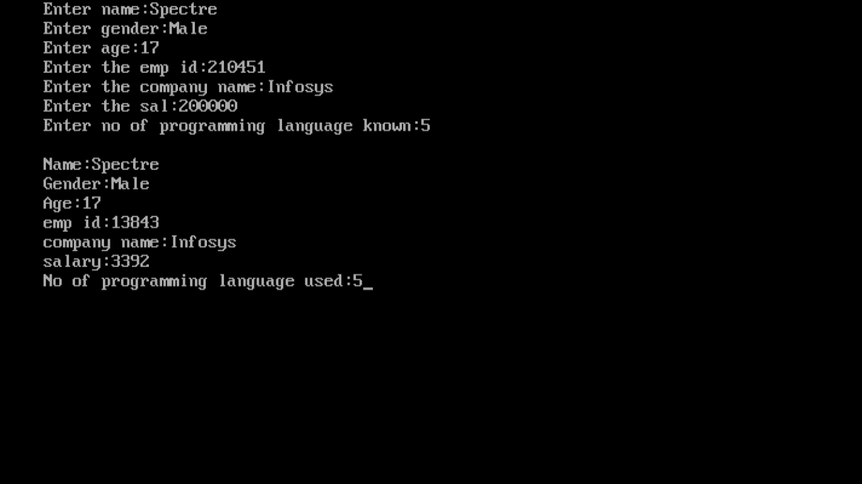

#include<iostream.h>

#include<conio.h>

class car{

char *cartype;

public:

void getdata(){

cout<<"Enter car type:";

cin>>cartype;

}

void putdata(){

cout<<"Car type:"<<cartype<<endl;

}

};

class brand:public car{

char *brand_name;

int speed;

public:

void getdata(){

car::getdata();

cout<<"Enter brand name:";

cin>>brand_name;

cout<<"Enter speed in mph:";

cin>>speed;

}

void putdata(){

car::putdata();

cout<<"Brand name:"<<brand_name<<endl;

cout<<"Speed in mph:"<<speed<<endl;

}

};

class model:public brand{

char *model_name;

long int price;

public:

void getdata(){

brand::getdata();

cout<<"Enter model name:";

cin>>model_name;

cout<<"Enter the price:";

cin>>price;

}

void putdata(){

brand::putdata();

cout<<"Model name:"<<model_name;

cout<<"Price:"<<price;

}

};

void main(){

clrscr();

model c1;

c1.getdata();

cout<<"\n";

c1.putdata();

getch();

}

